Organic Human Motivation
A General Critical Theory for the Social Sciences

[An Independent Dissertation]

Daniel Raphael, PhD
Cultural Agent Provocateur
PO Box 2408
Evergreen, Colorado 80437 USA
daniel.raphaelphd@gmail.com
303 641 1115
September 2022

Raphael/ Social Sustainability/ 1.02.07-DISSERTATION_Human_Motivtn | 9.7.2022 09:42 | Words: 13 508

Approved for Free Cultural Works

You are free to:
Share — copy and redistribute the material in any medium or format;

Adapt — remix, transform, and build upon the material for any purpose, even commercially; with the

Proviso — that attribution is provided in all cases.

ABSTRACT

The following is an independent dissertation that will examine human motivation from a new perspective, one that will apply to all social sciences as a General Critical Theory. This perspective will in turn affect almost all traditional social science theories, particularly human motivation and ethics, for example. As all human behavior, individually and socially, originates from Homo sapiens’ genetic behavioral codes, all human behavior is logically integral to all of the social sciences. Cognitive processing of the expression of those codes allows for multiple interpretations of those basic code expressions. To date, there has never existed a comprehensive, inclusive basis for a general critical theory that applies to all and each of the social sciences.
The human genome is the source for urges and impulses that initiate the motivation of decision-making and action. All that is human begins there. Our discussions will include values, human motivation, priorities of decision-making, ethics and morality, and an organic philosophy.
What the world is really seeking at this time is a unifying influence that is non-exclusionary, non-privileged, non-political, non-religious, non-gender specific, universally applicable to all societies and all people, and most of all that provides timeless solutions that can be implemented from the local level onwards to the national level. The single element of a unifying awareness as a topic of influence has yet to find a universal social science theory that harmonizes those levels of awareness into a universally recognized commonality of us all. Ironically, that commonality, human motivation already exists in the genome of every person.
The intention of this dissertation is to provide the missing constants that will bring the social sciences into an integrated holism of understanding that would support their practical applications to create a holism of all social sciences, and the development of integrated social policies and social programs. These constants are the genetic urge-impulses that initiate human motivation to consciously or unconsciously decide to take action or not.
Fundamental to those developments is the awakening of a conscious societal intention for the very long continued existence of our nations and civilization. Just as individuals seek purpose and meaning for their lives, when we appreciate societies as living social organisms we, all people, need to assign our societies purpose and meaning in order to organize societies’ existence in terms that support their capability to transcend the tragedies of all past failed societies.
This paper will examine the origination of human values, from where they emanate, and how they affect human behavior. These explanations will be followed by discussions of how these newly discovered constants will affect the development of proactive social policies and social programs to bring about improved social stability, social integration, peace, and social sustainability.
This conclusion will confront readers with the moral and existential question of choosing between the eventual decline and collapse of civilization, or the inconvenience of choosing to design socially sustainable, socially stable, and peaceful societies for future generations who must endure or benefit from what we have done to them or for them.
—

TABLE of CONTENTS

iii. ABSTRACT
v. TABLE of CONTENTS
vii. GLOSSARY

1. PREFACE
4. PREMISES
5. A Journey of unexpected Discoveries
The Social Sustainability and Validation Schematic (Evolved Version)
Discovery of the Four Primal Values of Our Species
Statistical Proof of Their Existence
The Four Primary Values
11. CONCLUSION #1
Characteristics of Human Values
Human Motivation
12. CONCLUSION #2
The Three Secondary Value-Emotions
14. A Unified Theory of Human Motivation
The Priorities of Human Motivation
17. CONCLUSION #3
Human Needs
Values and Decision-Making
Consistent, Quality Decision-Making
The Moral and Ethical Logic-Sequence Explained
22. CONCLUSION #4
A Universal, Timeless, Operational Organic Philosophy
A Philosophy Is …
An Organic Philosophy Provides …
A Framework for Logical Philosophical Examination
Writing an Organic Philosophical Statement
26. CONCLUSION #5

(Continued on next page.)

27. APPLICATIONS
28. Agenda for Sustaining the Existence of Humanity
and the Organizational Existence of its Civilization.
The End of War — A Vision for Humanity and Our Civilization.
The End of War — An Intention
The End of War — An Operational Philosophy
The End of War — Our Mission(s)
The End of War — Our Objectives
31. Reinvention of the Social Sciences

40. BIBLIOGRAPHY

GLOSSARY of Terms

“Urge” and its equivalent, “impulse,” are initiated by the human genome that produce human motivation, decision-making, and action. These are not taught or learned, but are inherent to the Homo sapiens species.
Humanity — the totality of all people and their future generations.
Civilization — the organized existence of humanity, from the first hunting bands to complex, contemporary private and public existence.
Organizational matrix — the interdependency of all organizations that holds our civilization together as a functional, operational social organism.

PREFACE
Let us begin with two metaphorical stories.
There are some situations in life that cannot be resolved by using traditional methods, or by trying to reenact the methods of achieving past successes. The world’s situation now, one of tumult and chaos, complexity and ambiguity at the same time, is similar to the ancient Greek legend of the Gordian Knot. It was proclaimed that anyone who untied the incredibly complex knot would become ruler of all Asia. https://en.wikipedia.org/wiki/Gordian_Knot
One person came forward and reasoned that it did not matter how the knot was loosened. So he drew his sword and cut the knot in half with a single stroke. And that is the situation of our world and global situation in 2022. It is in great need of a decisive way through it.
The second metaphorical story is this.
There sometimes occurs a situation while using your personal computer that the keyboard locks up. And no matter what key is used to try to unlock it, it remains frozen. You have tried everything you know of to continue working productively, but nothing works! As a last resort, you realize that you will have to reboot your computer system. Before rebooting you realize that this break in the flow of your work would be the perfect time upgrade to a new operating system. As none of the keys will create the reboot, you simply unplug the computer from the wall socket and plugging it back in.
—
The text provides the sword that cuts through the Gordian knot of our world’s social, political, and economic problems. What is described will create a completely new perspective for the development of workable solutions for personal-to-international problems. That may sound astounding, and it is. The crux of the problems of our world today is that no pre-planning took place when our civilization was forming for what it would become during the course of its expansion. This has caused great confusion for all nations. Highly successful business corporations have learned that if you want to achieve certain goals they must make plans that lead their corporation to those desired results.
Consider that there has never existed a vision, intention, operational philosophy, universal, timeless, and proactive ethic and moral code of decision-making, and surely there is no mission with objectives for the existence and progress of our global civilization. Conclusion, it is time to reboot the operating systems of our civilization and nations down to the local level.
The world is about to get a global “time out” but of much greater magnitude than what the Covid-19 pandemic and Soviet invasion of Ukraine gave the world since February-March of 2020. In the tradition of all societal tragedies, the pause in the flow of our national and civilizational events that follow such global tragedies will give humanity time to reboot all national systems to finally do the pre-planning necessary to sustain the thriving existence of our future generations in the coming millennia. What will be necessary to do so is a radically new perspective of the genetic design of the human genome as it applies to human motivation to plan for the sustaining existence of our nations and to our global civilization.
This dissertation presents a general critical theory for all of the social sciences and has all of the necessary elements to cut through the Gordian Knot of our current national and global problems. It provides social scientists, peacemakers, and corporate and governmental planners with the necessary fundamental human-based motivation theory to produce new theories and projections in the fields of their expertise.
In the tradition of Max Horkheimer, the following paper exhibits the characteristics of his Critical Theory by providing conceptual and practical information to “liberate human beings from the circumstances that enslave them.” The breadth of the topics of “all things of people” of this paper encourages the title of this paper to become “a General Critical Theory” for the social sciences.
For those with a purely academic interest, Dr. Daniel Christian Wahl’s doctoral thesis contains Chapter 6, “Co-Designing Our Future: Meaningful Visions of a Sustainable Human Civilization,” that offers a perspective that is very familiar to this paper. It is available at:
https://www.academia.edu/9280210/Co-Designing_Our_Future_Meaningful_Visions_of_a_Sustainable_Human_Civilization_Chapter_6_PhD_Thesis._Daniel_Christian_Wahl_Design_for_Human_and_Planetary_Health_Dundee_University_2006
My preference, in keeping with Horkheimer’s provision, has always been to share something practical with the public, to “leave the world a better place” — something practical and operational that can be applied by local citizens who also want to leave a better society and a far more effective democratic process to their children and great grandchildren.
This may seem audacious, and it is, simply because at a time when all that we see in the local, regional, national, and international news are the causes of separation. What we want to see are the rational reasons for integration, wholeness, and to appreciate the universal and timeless holism of humanity in each individual. That has always existed, but perhaps our perspective has been out of focus because we have been too close to the problems to bring them into focus to see the possibility of potential solutions. We are the problem, and the solutions are within each of us.

Considering the global situation of the organizational matrix of our global civilization today that includes the over-population of the planet, multiple and simultaneous national and international crises, the Covid-19 Pandemic and subsequent economic decline, and of the Russian invasion of Ukraine and further subsequent economic decline, the old, traditional means of resolving local-to-international crises is grossly insufficient to answer humanity’s silent call for assistance. Something more, qualitatively, is needed than more guns and more money.
—

PREMISES
● Values always underlie decision-making.
● The Homo sapiens species has been in existence approximately 200,000 years, and we, today, are descendants of those ancient ancestors.
● Humanity is a culture.
● Values are at the core of every culture.
● Values are the fundamental and essential elements of ethics.
● Values always underlie ethical and moral decision-making.
● Values and ethics are the essential elements for developing priorities of decision-making.
● Values and ethics are the essential elements of philosophy.

A Journey of unexpected Discoveries
The following describes a chain of discovery of the origins of human motivation that begins with a personal experience that is described in the following pages.
Sustainability. In 2004, I had become acquainted with sustainability through media articles. It had become a common topic of discussion in local, national, and international media. Neighborhood recycling programs had been initiated in many cities around the country by those who had concerns for diminishing natural resources. My question, even at that early date was, “What about social sustainability?” and, “How do we sustain a beneficial social context for our families, and of our communities, and societies?”
First Workshop. As I expanded my knowledge about the unexplored potential of individual people and whole societies, I began to ponder the idea of teaching a five-day workshop about social sustainability; and to explore the meta-mind potential that could be accessed via relaxation and meditation, as a form of non-religious spirituality. That workshop took place at Snow Bird Ski Resort, Utah in October 2007.
Our work in the workshop made it necessary for me to develop a rudimentary procedural schematic for examining social issues of almost any type. (See illustration, page 6.) What necessarily followed was the development of a “design team” for working the schematic in a team setting.
Curious Students. Several students attended who were from our local community in Evergreen, Colorado. A few weeks after the workshop, three of the students bluntly asked, “Now what, Daniel? You’re not just going to leave us with this knowledge and not take us further, are you?”
In early December 2007 we began an Experimental Design Team that I had been developing for several years. Because the students had become acquainted with social sustainability, the interest of the majority of the group, which had grown to about twelve people, was toward sustainable social relationships.
“What should we work on, Daniel?”, they asked. I replied, “What would you like to work on?” My challenge was followed by an open discussion among the group. Their choice was to discover how to sustain intimate relationships, an intimate form of social sustainability at the personal level.
The Experimental Design Team and a Primitive form of the “Schematic.” We began with what I had learned in my own therapy experiences twenty years beforehand that I had developed into a rather primitive form of the evolved Schematic, illustrated below.
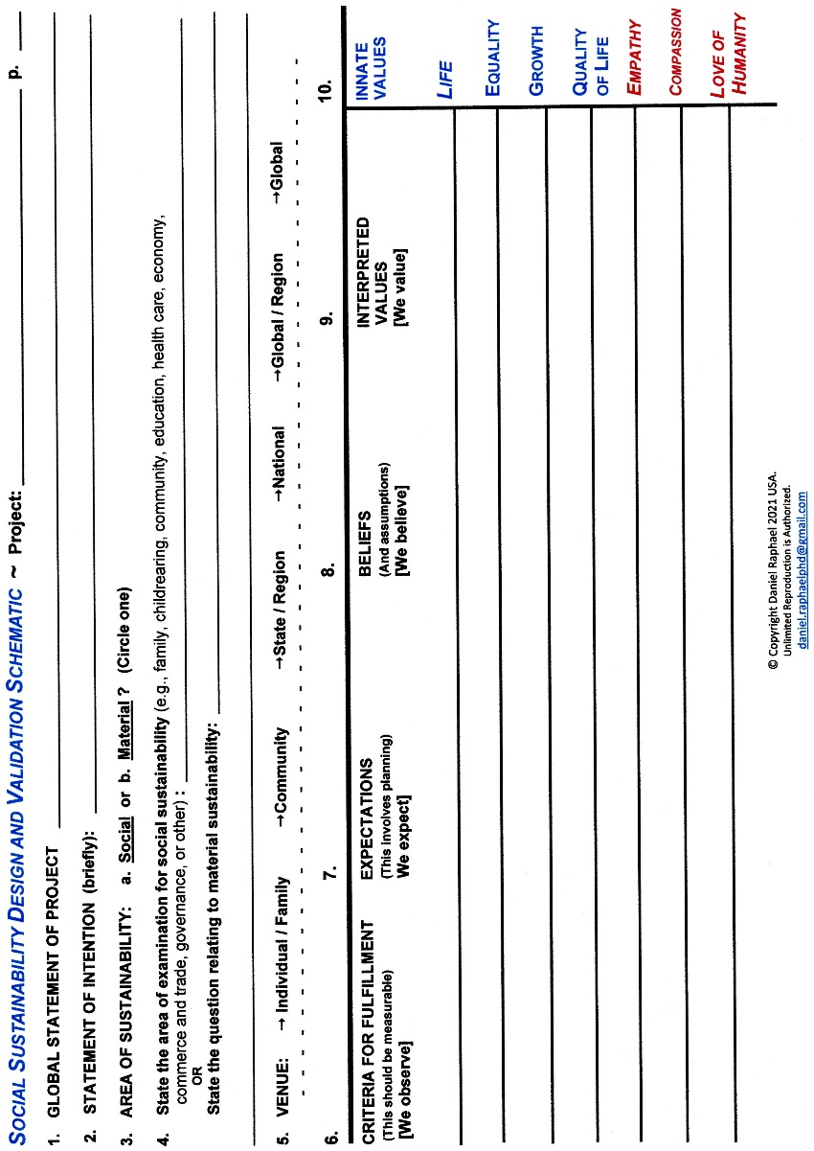
The team’s motivation to choose the topic “sustaining intimate relationships” arose as a direct result of the disappointment (column 6) almost all people feel when an earnest romance crumbles, when an engagement for marriage is revoked, and when the disappointment in a marriage relationship moves toward divorce. Our expectations (column 7) were for happiness and fulfillment, but the results were disappointment.

The Social Sustainability Design and Validation Schematic
The “Schematic” that I had been developing for over a decade helped our team tremendously to discern the origins of disappointment in intimate relationships.
NOTE: The full list of values in column #10 were discovered several years after the exploratory design team and the rudimentary schematic. My quest later was to discover the origins of those values.
Discovering the Causes of Disappointment in Intimate Relationships. The lineage that leads to disappointment is fairly easy to understand in hindsight. Avoiding disappointment in intimate relationships is difficult task simply because the hope of our expectations often rise to heights at a time when your relationship has not even begun to bud into a bonded, intimate relationship. Few people are well prepared beforehand for what develops in their intimate lives.
In the rear view mirror of our team’s hindsight, we discovered that disappointment was set-up by false or inaccurate expectations that were established by unreal and erroneous beliefs about intimate relationships that we had learned from the disastrous relationships of our parents, friends, neighbors, family, and from media of all types. Disappointment in any relationship is evidence that the people involved did not do their homework to assure their future relationship would lead to fulfillment and happiness. Because relationships always morph over time, it is essential at least yearly to review the intentions each person has for themselves, with the other person, and jointly for their relationship.
The really insidious factor of beliefs is the bedeviling assumptions that always underlie beliefs. Assumptions are really tricky to work with because we are rarely conscious of them! Reviewing intentions and then comparing the intentions of each partner in the intimate relationship usually provides the best entry point for exposing assumptions, and then to make adjustments.
In the team setting we discovered that when assumptions were accepted by the whole team that we all could be fooled into accepting our beliefs/assumptions as true, workable, and consistent with happy outcomes. Upon closer examination of individual experiences, we learned that shared assumptions did not always produce happy endings. We did, however, discover that if two people in an intimate relationship held the same belief-assumptions that they could easily glide along for years that way. Later, if one of the partners begins to explore the development of their potential, goes through a course of coaching, counseling, or therapy, or even night school educational experiences, that experience and new information often results in an increase of stress in the intimate relationship from the exposure of their assumptions.

Discovery of the Four Primal Values of Our Species
In our team’s discussion of disappointment, expectations, and beliefs-assumptions we had gotten to the point of awareness that values always underlie decision-making. The question we asked then was this, “What values underlie inaccurate or erroneous beliefs and expectations?” Obviously, the values we have been using to make decisions about our relationships had produced disappointing outcomes. We immediately knew that searching for inaccurate or erroneous values was not the path to follow, as those would change with each person. Logically, the values that we had assumed were correct, in reality they were erroneous interpretations of the seven primal values, and not the best ones suited for a happen ending.
Interpreted Values. What we discovered in the early weeks of our team meetings was that we had unconsciously assumed that the value-interpretations we had been using were the basic values for determining what would lead to happiness and fulfillment in our intimate relationships. We had discussed various values as being pivotal to the development of reliable relationships. We could tie LIFE as a pivotal value for the work that we had completed, but we struggled to discover the interpreted values related to LIFE that would help us make decisions to produce happiness in our relationships. What we did not have were the seven values illustrated below. What occurred next was nothing short of a miracle that helped us proceed.
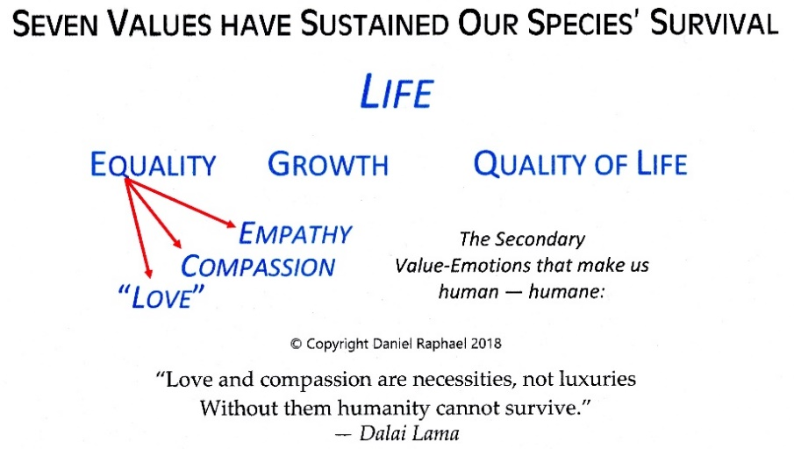
The Ah-ha! Moment. Once in a while life gives us an “Ah-ha!” moment that provides a clarifying insight that enters our mind like a lightning strike with all of its impulse of energy. For me, it occurred after one of our weekly Team sessions while we socialized in the kitchen. Returning to the living room to prepare to go home, I stopped mid-stride with the insight of four fundamental values that underlie all human decision-making from time immemorable — Life, Equality, Growth, and Quality of Life. These four fundamental values underlie all human decision-making. I immediately wrote those values down in my notebook.

To short-cut a long explanation, the short version is that these four primary values are the fundamental values that underlie almost all human decision-making in all of the history of Homo sapiens. They are also the source for all interpretations of those values. They have given our species the capability to adapt, sustain our survival, and to strive, overcome, and achieve immense growth as a species individually, socially, and in organized societies. Yet, for all of the dynamic growth those four primary values have provided, they have also brought about the profound disappointment of failed civilizations, societies, and cultures over the last 20,000 years of organized social existence of humanity, and profound grief for how they were used.
Statistical Proof of Their Existence
The commonalities of the behaviors of all people over the course of 200,000 years suggest the existence of a set of motivator-values with their primary function being to guide decision-making to ensure the thriving survival of our species.
Readers have probably already noted that there is no scientific physical genetic evidence to support the author’s proposition that these values do indeed exist at the genetic level. On the other hand, neither can they be proven not to exist. In lieu of genetic location identification of these values, the statistical method to prove their existence would be the most reasonable route. Our team then assigned ourselves to ask our friends in this and other nations around the world if those four primary values were important to them, and if they felt that those values were primary to the development of their lives. And, yes, there was almost total agreement.
Because you as the reader are one of the statistical population you can ascertain the validity of these values, at least for yourself. Asking your friends and associates whether they make decisions using these values and interpretations of these values would extend your statistical proof.

The Four Primary Values
Life. This is the value that is common to all living creatures, even bacteria. We know life is important to all living beings by the evidence of their reaction to life-threatening stimuli that causes some level of pain.
We could say then that LIFE is the ultimate value of living creatures, excluding viruses and fungi for example.
Equality. This value is much more complex. The sense or awareness of INequality is the stimulus that arouses decisions and behaviors to reconcile that imbalance.
The key to understanding INequality is awareness. If a creature is not aware of being treated UNequally, then individually INequality does not exist for that creature. Behavioral laboratory experiments have proven that an awareness of UNequal treatment is exhibited in most mammals, particularly primates; and, very evident in humans.
Growth. Growth is an even more complex value. Physical growth is exhibited in all living beings, even simple multi-celled creatures at the microscopic scale. Mental growth is not so obvious but evident in the creature as it develops physically, meaning that the brain is capable of taking on the task of solving more complex problems and routines.
The full development of physical, mental, intellectual, emotional, social, cultural, and spiritual growth seems to require some level of curiosity, which is enhanced when the individual strives to satisfy that curiosity.
There seems to be an innate limit to the individual’s capability to satisfy their curiosity, and that appears to be due to the innate potential the individual brought into life. What is paramount to the accomplishment of striving to fulfill an insatiable curiosity is a statement similar to “I can do this!” And if that person becomes aware that they do not have the skills, whether they are skills of dexterity or mathematics manipulation, or mental capability to accomplish the task that curiosity presents, the value “growth” usually urges the individual to learn those skills so that they can proceed, and possibly proceed successfully.
Most mammals have this “urge to grow,” but only humans have self-awareness and the innate capability to decide to grow. For humans, the urge to grow, and then the consciousness to decide to grow is innate. To will to grow is to be human.
Quality of Life. Quality of life as a value is distinguished from social comparisons. We can observe decisions that generate behaviors to improve one’s quality of life. For example, people had the choice to install electricity and indoor plumbing after the invention of electricity that produced electric lighting, electric water pumps to create pressurized water in a home, leading to indoor toilets.
Social comparison is not related to improving one’s quality of life. To choose to trade-up from your one-year old Buick to buy a Bugatti sedan; or, to buy an 8,000 square foot home when the two of you were living quite well in your 3,000 square foot home is a matter of personal choice that was initiated by a person’s ego needs. Bigger and/or more expensive does not equate to a “better” quality of life.
The value quality of life is fulfilled by a combination of the values of life, equality, and growth. The behavioral evidence in archeological research has shown the development of dwellings from caves and lean-to shelters, to various forms of yurts, wikiups, various types of tents, mud huts, rock huts, log cabins, and dimensional lumber houses, with the size of such dwellings determined by the number of the people who would regularly use them.

CONCLUSION #1
Just as all species are “driven” by the genetic codes of their DNA to behave in particular ways, similarly Homo sapiens are unconsciously driven to behave in particular ways, except upon reconsideration they consciously choose to do otherwise.

Characteristics of Human Values
When we say that these urge-motivator-values emanate from the human genome, then that confers certain characteristics to those values. These would include being …
…timeless, meaning that these values, as exhibited by decisions and behaviors, existed in humans 200,000 years ago, in us today, and in our progeny for the next umpteen generations. Archeological evidence should be present that identify those values what they produced by prior civilizations, cultures, and nations;
…universal, meaning that they exist in all humans of every race, gender, ethic group, culture, nationality, and in every person who ever lived, is alive now, and those who will be born in millennia to come. Archeological and present evidence should show that these values would be expressed in cultures and civilizations worldwide in any and all eras of human existence;
…irreducible and immutable, meaning that when we put a name on the values underlying our decision-making, as evidenced by our behaviors, that we will come to the awareness that there are no other values that underlie these values and behaviors. In other words, these values as motivators would not be interpretations of other more basic values, but that these values would be proven to be the only basic values that are common to all humans;
…self-evident, meaning that these values and subsequent behaviors are so obvious that they have been overlooked, ignored, and not recognized for themselves. They would be so intrinsic to our own personal being that we would not have identified them except in extreme situations, as those that resulted in the United States Declaration of Independence, “We hold these truths (values) to be self-evident, that all [people] are created equal, that they are endowed by their Creator with certain unalienable Rights, that among these are Life, Liberty and the pursuit of Happiness.”
Human Motivation
“From what place of origin do values emanate?!” The answer lies in the very existence of our species, from within the human genome. Values originate first as unconscious “urges of motivation” from within the person. Life is the value we identify from our urge to continue living; equality is the urge to be of equal worth as anyone else; growth is the urge and motivation to expand the individual’s capability to live more fully. These three primary values work together to fulfill the urge to achieve an improving quality of life.
Because we were never taught to be thirsty, hungry, or to breath, which are needs derived from the primary value LIFE; and neither were we taught to sense INequality, or the need to learn new skills, or to want an improving quality of life. We simply know that the urges that initiate our motivation to make decisions to fulfill those needs come from within us. They are not manmade values. We identify these urges and motivation with the word “values” that originate from the human genome.
These urges of motivation, which we call “values,” are inherent in being human. They are not learned, but exist at the genetic level and innate to our species. The four primary values provide the unconscious urge of motivation to sustain survival and to thrive. The three secondary values of empathy, compassion, and a generalized love for humanity also exist as urges of motivation, but enacting them is volitional, a matter of conscious choice.
We can see, then, how values are so closely related to ethics and decision-making because they emanate from the genetic core of our species as urges of motivation to choose, i.e., make a decision, of what is good for us or not.

CONCLUSION #2
The discovery that these urge-motivator-values emanate from the genetic code of the Homo sapiens species provides that all subsequent developments of explanations for the various forms of human behavior will always be able to point back to their source. As well, seeking the ultimate source for understanding the social sciences will always lead back to the urging of the genetic codes that motivate the individual to make conscious or unconscious decisions to take action, or not.

The Three Secondary Value-Emotions
Equality Empathy, Compassion, and Love
The source for these secondary value-emotions is the primary value Equality.
The value-emotions of empathy and compassion are more evolved and refined forms of the primary value equality. We know when equality is out of balance because of the secondary value-emotion of empathy – to “feel” or put our self in the place of another person and sense what that is like, whether that is in anguish or in joy. When we feel empathy for others, the value-emotion compassion motivates us to reach out to the other person and assist them in their situation. When empathy and compassion are combined, and we feel that equally for everyone, then we say that we have a love for all humanity — the capacity to care for another person or all of humanity, as we do for our self.
Empathy and compassion are evident in more evolved primates that exhibit behaviors similar to those of humans. Some species of monkeys will exhibit concern (empathy) for another monkey or human who is in distress as we see from the various facial expressions that are similar to what humans exhibit when they see another person in distress. Such behavior reflects that empathy is not a learned behavior but is innate.
What is remarkable is that some primates will then exhibit compassion by going to the distressed animal or person and try to console them in one way or another. This too seems innate. The combination of empathy and compassion expressed as a generalized love for humanity seems to be innate only to humans. Those people who do express a generalized love for humanity see themselves as a member of the larger population of human civilization. They know that they are one of that larger population, and that the differences of race, skin color, culture, ethnicity, gender, political and national affiliation are external. The identification is within each person, that we are all of one species, Homo sapiens, with a common history of struggle and overcoming.
The awareness of situations in which a person struggles, as we personally have struggled, lends to a developed self-awareness as we empathically place ourselves in the other person’s life in that moment. It is not something we were taught, though it helps to have learned empathy from parental figures and others. The innate value-emotions of empathy and compassion always lie latent within each individual and can be strengthened. It then becomes a personal decision to act on the impulse of empathy to compassionately aid the other person.
Empathy, Compassion, and a Generalized Love for Humanity support the development of a higher quality of life for our self and for/with others by providing the motivating energy to grow into a more complete, mature, and functional individual within our self and within our social environment. These values allow us to see the common good as societal rather than selfishly personal. Their expression demonstrates the highest ennobling qualities of human nature at its best. With these three value-emotions, we have the direction and motivation from which to develop highly positive family dynamics; and a loving, compassionate, and empathic means for validating the holistic growth in individuals, families and societies.
When we consciously become aware of the already internalized primary values and secondary value-emotions, we realize that the collective power of individuals affects individuals everywhere as much as the individual affects the collective whole. Acting accordingly, we have the capability to become the highest living expression of being fully human.

A Unified Theory of Human Motivation
The “unified” aspect of this theory of human motivation comes about at two levels.
The first points to the personal level. It points to the genetic based origins of the “urge-impulse” level that sparks the motivation of the individual at the conscious and/or unconscious level of awareness. At that point, the individual will be aware enough or not to consciously make a decision to either take action or not on the motivation of that urge-impulse.
For individuals, life becomes a process of surviving and thriving.
The second points to the social level. ● Knowing that the identity of the urge-impulses-motivators is universal to all people and timeless as the genome of the Homo sapiens species, we can develop codes or rules for consistent ethical and moral decision-making. For humanity, as a social product of many people interacting, consistency of decision-making is essential to the survival, existence, and thriving progress of associations of many individuals, (cities, for example), organizations, (governments, companies, corporations, and school districts, for example), and the existence of families, communities, and societies.
● From the creation of universal and timeless rules of ethical and moral decision-making, we can create a philosophy of living that equally applies to individuals and to associations of individuals.
For social entities of human civilization that create the organizational matrix of civilization, survival, existence, and thriving have never been confronted to establish the organizational necessities that will assure social progress and social evolution. The problem, of course, is that it appears that societies, communities, and neighborhoods have never been seen as living social organisms that provide a nurturing and protective “envelope” to the individual/family and their communities. Were we to value them with that quality, we would want to use a format for organizational development what would assist those ends to come into being. The following questions lead the way.
What is the vision we would assign to the existence of a national society, for example?
What is the intention we would assign for the existence of a national society, community, and neighborhood, for example?
What is the operational philosophy we need to create that applies to all aspects of human existence, its civilization, and all organizations?
What is the mission of civilization? And,
What are the objectives of nations, states, cities, and all organizations to fulfill the designs we will create our organized social existence?
These existential questions cannot be answered without a unified theory of human motivation that begins at the genetic level of individuals and extends to the survival and existence of all humanity and through the organizational matrix of our civilization.
The benefit of using a unified theory of human motivation is that it will organize the relationship of organizations so that their individual and collective intentions become complemental to sustain the survival and social evolution of societies — and that their social and public policies will create integrated, complemental social programs to fulfill that end. (See, “Reinvention of the Social Sciences,” page 33.)
—
Understanding human motivation is essential for understanding the reasons people make the decisions they make, and have made in the past; and to predict how people in larger and larger groups will behave. If we thoroughly understand the fundamentals of the motivating energies of the seven values, then an understanding of human motivation can make social, economic, political, and even military planning far more effective. At the national, state, and local level, planners will become more and more aware of human motivation in the dimensions of the seven values. They can then begin the developmental and evolutionary stages and steps necessary for a democratic society to evolve to transcend its beginnings and the failings of past and present social institutions, and their organizations.
The synergism of the primary and secondary value systems gives us a complete picture of human motivation and an accurate reflection of us as individuals — thinking and compassionate, analytical and creative. The four primary values and the three secondary value-emotions bring us full circle to provide the basis for a unified theory of human motivation by engaging the analytical-side of individual and group activities with the creative, intuitive, and heart-connected side of our human existence.
We are motivated by our intellectual side to devise ways to improve our quality of life, whether that means discovering fire to heat our cave and cook our food or inventing the latest smart phone. We are also highly motivated by our creative, artful side of our being from what most people feel in their “heart.” The secondary value-emotions give each of us the capability to improve the quality of our lives through our empathy, compassion, and love for humanity, both as givers to others and as receivers from others.
Further, these values give us the motivation to improve the quality of our lives through our intra-personal relationship with our self; and our inter-personal relationship with others. This is the point where the unification of these two value systems becomes vastly important to motivate each of us to explore our innate potential to create a balanced holism in our life, to confidently unlock our potential, and aid others to unlock their own. The three secondary values connect us to others through our empathy to act in compassion to aid others. The conscious use of the combination of these seven values reflect that we are being fully human. Peace will never become possible until we become fully human in our intra- and inter-personal relationships.
These seven values have provided the motivating impetus to sustain our species for approximately 8,000 generations and characterize our species as being human, humane. In other terms, the four primary values give us an integrated system of moral justice; and the three secondary values give us an integrated system of humane justice. The three secondary value-emotions give us the criteria to live our lives humanely in grace, to protect and nurture our self while we protect and nurture others.
The Raphael Unified Theory of Human Motivation. Together, these seven values provide us with a unified theory of human motivation. Eponymously, it becomes the Raphael Unified Theory of Human Motivation.

The Priorities of Human Motivation
The genetic source of the seven primal urges of our species function to preserve the species, just as every other species does, with the exception that for humans, the three secondary urge-motivation-values have a function of their own. The function of the secondary values is to smooth intra- and interpersonal relationships, and also to sustain the preservation of the organizational matrix of societies of nations.
The illustration below shows the dynamics of the primary values and secondary values at work.
The function of the four primary values of the human genome is to preserve the species. Over the course of many thousands of years these four genetic urges eventually brought about the invention of manmade fire and later the creation of many thousands of inventions, along with the development of clans, tribes, nations, and the organizational structures of societies.
The illustration shows that if the species dies, then the organizational structures of societies die, including the organizations themselves.
There is a necessary symbiotic relationship between organizations and the individual/family to sustain and improve the functioning of the organizational existence of our civilization, and the quality of leadership of organizations. In doing so, communities, societies, and civilization passively receive quality-improvements to their existence.
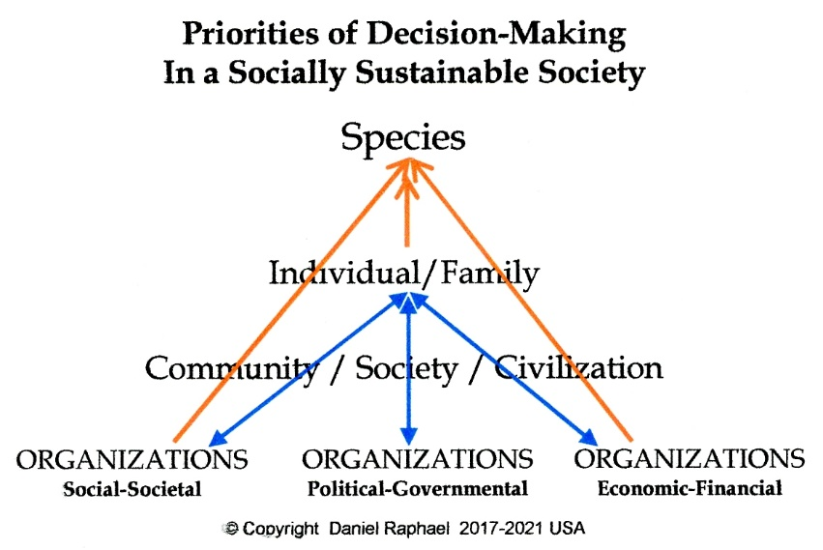
The double-ended blue arrows between the individual/family and organizations pass through community/society/and civilizations simply because they do not exist as locatable entities with a GPS or physical mailing address.

The sad state of the current quality of communities, societies, and the whole of civilization is due to the lack of volitional, conscious and intentional societal planning for quality-improvements of the individual/family, communities, and societies by decision-makers in the three pillars of societal architecture. That requires the conscious and volitional use of the three secondary value-emotions by decision-makers of organizations within each of those three societal structures.
The ongoing deterioration of social and societal performance came into existence simultaneously with the rise of the organizational matrix of societies and has been due to dominating urges of the four primary values. They act automatically, unconsciously, without the need for citizens and their decision-makers to conscious invoke them to increase the complexity of societies, with the concomitant decrease in the quality of social and societal life of citizens and the public, collectively.
The missing element that would correct that situation are the necessary “rules for consistent, beneficial decision-making” that are developed from the four primary values and the three secondary values. (See “Ethics and morality of the seven values” beginning on page 22.)
—
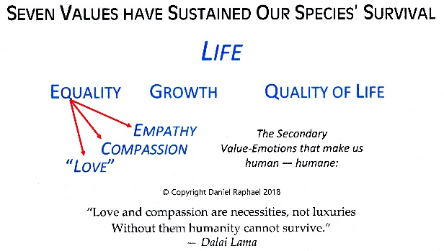
The effect of the seven innate values is to act as innate motivators for decision-making with subsequent behaviors that fulfill or satisfy the urges they develop. When we examine these seven values as primary and secondary values, we gain the insight that the four primary values are responsible for the growth of large organizations.
The three secondary values are responsible for urging us to consciously form, develop, and evolve intentionally functional organizations and subsequent societies. Their function is to motivate all of humanity to include empathy, compassion, and a generalized love for humanity in the decision-making practices by individuals, individuals collectively, and by decision-makers in organizations.
The essential function of three secondary values in organizations is to improve an organization’s ability to survive by making them more humane in their decision-making and their actions. This may seem ironic in view of the four primary values as aggressively necessary to assure the fulfillment of the organization’s ability to survive. This is where the wisdom of the organization’s decision-making leaders and bodies must come to bear so that all seven values underlie their decisions. Survival and then sustained existence then become the foundations for the transcending existence of whole societies and their nations.

CONCLUSION #3
Human motivation is essentially selfish to support the survival and then the improving quality of life of the individual, and then of the larger group. The four primary values dictate the priorities of decision-making for the individual and their immediate group. The secondary values can then motivate individuals to take into consideration the life-situation of others.

Human Needs
As explained by Dr. Abraham Maslow, who created a hierarchy of needs of our species, the basic needs, (physical and security) originate as innate urges to sustain our life. Dr. Maslow stated that as basic human needs are fulfilled more evolved needs become apparent to form a hierarchy of needs. What Dr. Maslow did not tell us was that as we are able to satisfy our needs, our innate urges motivate us to interpret them in new ways to develop new needs and new hierarchies of needs. Our hierarchy of needs evolve as our interpretations of our innate values evolve — we are still using the same value system as our ancestors did tens of thousands of years ago, but we interpret them in new ways.
From the discussion of the seven values, we can make at least two very important conclusions. First, the four primary values motivate humans UNconsciously to make decisions that provide for the survival of the species. Second, the three secondary values urge humans to make conscious decisions to act on their urging. The secondary values act as modifiers or qualifiers to the primary values which necessitates their subsequent moral and ethical rules of decision-making.

Values and Decision-Making
The presence of these values has three functions.
1) To guide decision-making;
2) To guide decision-making to assure the physical survival of our species. Because we know that values always underlie all decisions, the presence and purpose of the four primary values, (life, equality, growth, quality of life), are to ensure the survival of the species;
3) To guide decision-making to assure the organizational survival of our societies and nations. Because we know that values always underlie all decisions, the presence and purpose of the three secondary values, (empathy, compassion, and a generalized love for humanity), are to ensure the survival of the organizational context of our societies and of our civilization.
—
History has proven that though the four primary values have sustained the survival of our species, they have not been sufficient to sustain the survival of the organizational context of societies, cultures, civilizations, their nations, empires, or dynasties. The 20,000-year history of the organizational social existence of humanity is a record littered with the consistent failure of all civilizations, cultures, societies, and nations, along with their governments, administrations, and policies.
While forging a successful and dominating nation requires the firm use of the four primary values, once that achievement is secure, then the use of the three secondary values must be included to sustain that level of success indefinitely.
As we know only too well, domination that is often termed “success” can be achieved by beating the bloody-hell out of another nation, but once that is accomplished, it requires a co-operative and co-ordinated teamwork approach to sustain those victories into centuries and millennia.
The history of the rise and fall of nations is also a history of strong male leaders who were necessary to settle the frontiers of human expansion. But those times have passed! Now we live in a world that is fully occupied with nations that exist in close relationship with each other. International relationships do not survive when nations and their leaders are aggressive, unruly, bullying, or manipulative of others.

The feminine capacity for cooperation and coordination is essential to the fulfillment of 2nd Stage Democracies to become 3rd Stage Democracies. The feminine is essential to sustain the success and longevity of any nation by balancing the male impulse of domination, by authority, position, and power. The feminine adds qualitative elements to the systems that sustain survival and continuing existence that emanate from our secondary value-emotions.
In order for democratic nations to survive, the decision-making practices of their politics, governments, administrations, and policies must begin to use the whole spectrum of the seven values, plus the morality and ethics that erupt from them, i.e., the rules for consistent ethical and moral decision-making, that must become inherent in the “rule of law.” Any political party of a democratic nation that wishes to remain in power for centuries must begin to assert these values, and particularly their ethics at a time when those values and ethics are desperately needed.
The three secondary value-emotions (empathy, compassion, and a generalized love for humanity) are essential to the possibility of social stability and peace by including them in decision-making to achieve those ends. What we know, though, is that their application in decisions is totally volitional. That is, to be humane requires the decision-maker to become aware of their own motivational impulses of empathy. To act, or not, on that impulse is a volitional ethical/moral decision to take an action that is humane, compassionate, and even merciful in some cases.
With this degree of clarity of the human urge-motivator-values that sustain our species and the organizational context of democratic societies, determining what is ethical and what is unethical, what is moral and what is immoral, becomes incredibly clear. Codes of ethics and morality, derived from the seven values, exist to maintain consistent ethical and moral decision-making for the survival of our species and our societies. The operational philosophies that we can then develop from those values, morality and ethics become far easier to write, understand, and apply than ever before!

Consistent, Quality Decision-Making
The great benefit of these seven organic values is that they provide the foundations for an organic, integrated code of ethical and moral decision-making.
Moral Decision-Making provide us with a set of rules to guide human decisions and actions to prevent destructive, life-altering behavior in human interaction; and to improve the life and living conditions of others.
Ethical Decision-Making provides a set of rules to guide human decisions to maintain and improve relationships.
What has been missing for making more reliable and consistently ethical and moral decisions is a set of values that have a proven record of their effectiveness. The seven innate values of our species fit that criterion perfectly. Their capability has been validated by having sustained our species’ survival for over 200,000 years. They provide the basis for a universal morality and ethic that have the capability of sustaining the organized social existence of our civilization for a similar length of time.
The crucial element that will make that possible is for most people to begin using those values, ethics, and morality of their decision-making. The logical link between all of human existence stems from the two fundamental elements, individuals and their innate values. Individuals make decisions for their own personal lives, and as members of organizations they also make decisions in behalf of those organizations, and humanity.
The Moral and Ethical Logic-Sequence Explained
Seven Values Moral Definitions Ethics Statements
Expressed Ethics The Graces of Expressed Ethics

The Four Primary Values, life, equality, growth, and quality of life, primarily address the continuance of life and living and all aspects that affect the quality of life and living. They act in unison. When one of the four values is violated, they all are violated. They provide an integral approach for understanding the moral necessities that support life and living.
By extension, logically, any action that jeopardizes equal treatment of a person’s life is also an immoral act. Similarly, any action that jeopardizes a person’s capability to grow into their innate potential is also an immoral act. Separately, or conjointly, any act that jeopardizes the victim’s capability to improve the quality of their life are also immoral.
The Three Secondary Values, empathy, compassion, and a generalized love for humanity, are the value-emotions that act as the criteria for identifying people as being humane, the highest, evolved social level of being human. The three secondary values identify the ethics of interpersonal and organizational decision-making and actions that particularly address the “quality of life” of those relationships.
The priorities of decision-making to create a self-sustaining, transcendent nation in terms of a millennium require the conscious decision by all players in that plan to move from the unconscious, knee-jerk response of getting more, to conscious, volitional efforts to improve the quality of the individual’s life, family life, and the larger society.
In the long term of an organization’s existence, the three secondary values are not at cross purposes with the four primary values because, wisely, both sets of values work toward the same ends. The motivation for using the three secondary values of empathy, compassion, and a generalized love for humanity in decision-making ensures that the deeper purposes and meanings of life and living are taken into consideration.
The three secondary values urge us to design the organizations associated with each respective social institution, as the family, education, healthcare, justice, and the democratic process for example, so that they intentionally sustain the good working order (functionality) of our families, communities, and societies. The primary values motivate the public to design organizations to fulfill the needs of citizens and to ensure that they can maintain their lives and life styles. The secondary values ensure that our organizations, societies, and communities are livable.

CONCLUSION #4
The core element that provides for human motivation to make decisions are the organic urge-impulses that initiate the motivation of human behavior. Fortunately, the integral nature of these seven impulse-motivator-values provides for the logical development of consistent rules for ethical and moral decision-making.
These values, ethic, and morality provide for the rational, integrated designs of the social sciences, and their social theories of each social institution.

A Universal, Timeless, Operational Organic Philosophy
As humanity is the holism of all people, civilization is the holism of humanity’s organizational existence. To enable these two elements to be successfully sustained into the coming millennia, nations and societies must express and live by an organic philosophy that encompasses all that humanity is and can become. It, too, must be universal to all people and their nations, timeless in its encouragement to ward against the tragedies and cataclysms of the onward progress of civilization. Such a philosophy must be as applicable to future generations as those of today. And, it should be the esprit of civilizational maturity.
The author’s Organic Philosophy introduces an integral, universal, and timeless philosophy for sustaining the thriving existence of humanity. As such, it can be used by any organized effort that has the motivation of humanitarian interests at the heart of its existence to make meaningful and lasting contributions to the organizational structures of democratic nations and their societies.
To use an organic philosophy effectively, we must come to understand the basis for its existence and the characteristics of that basis that give it timeless and universal flexibility. Labelling it with a name says little about this Organic Philosophy, but understanding the reasons for its coming into existence at this time makes it relevant to the societies of civilization to make a leap of consciousness that is necessary to successfully overcome the challenges of a world in transition. We, all developed democratic nations, are now moving agonizingly from post-monarchical consciousness to a new era of consciousness of shared responsibility for the survival of mature societies that are in great need of evolving.
Rise of a New Consciousness. Of great significance for our times, the rise of human consciousness worldwide that begin in the 1950s and became evident in the cultural upheavals of the 60s and 70s continues more popularly today. Global consciousness has risen to the point where almost all forward-thinking individuals of national populations are seeking answers from outside of traditional institutions and organizations of power.
The benefit of using these seven motivator-values is that they provide the same basis for decision-making that our ancient ancestors used in the last 200,000 years to sustain the survival of our species. Not coincidentally, these same motivator-values provide the basis for a uniform and organic universal ethic and morality to guide decision-making. Together, these provide for the creation of an “organic philosophy” for informing and guiding individuals and all organizations into a socially sustainable future, not for a few years or a decade, but for centuries and millennia.
The first component of a Universal Organic Philosophy is the seven motivator values that are organic to the human genome. Those urges motivate and mobilize humans to act upon their initiation. They have been labelled “values” for being of eminent importance to humans, and define us as being human, humane.
The second component of the Universal Organic Philosophy is the organic ethics and morality that are subsequent to those values. They are the rules for making consistent ethical and moral decisions. The seven values, then, underlie moral and ethical decisions that will sustain the survival of the organizational matrix of society just as they have sustained the survival of our species for over 200,000 years.

A Philosophy Is …
1. … a belief (or system of beliefs) accepted as authoritative by some group or school;
2. … the rational investigation of questions about existence and knowledge and ethics;
3. … any personal belief about how to live or how to deal with a situation. Source: WordWeb Pro
An Organic Philosophy Provides …
● …a timeless and universal guide for decision-making that is fully complemental to the value structure of the Homo sapiens species.
● …a guide for designing social institutions and social sciences to contribute to the very long term social stability and sustainability of society. As such, it is highly useful for validating long term planning and plan execution; and for testing for validation of existing laws, policies, and guidelines.
● …one of the essential elements of organizational development planning, policy writing, and implementation.
● …a permanent ethical and moral standard for all human interactions, individually, and organizationally.
…for the integration of social science theories into a holism for the development and evolution of social-societal systems among social institutions and their relevant organizations.

A Framework for Logical Philosophical Examination
The challenge of creating a timeless and universal philosophy is to define “what is right” for individuals, associations of individuals, and other organizations as your organization interacts. The values, beliefs, and ethics that you devise will give direction and guidance to your organization to deal with situations of life and living that contribute to the good of humanity.
An organizational, organic philosophy moves from being a platitude to be forgotten to one that is essential to sustain consistent decision-making to sustain the organization into the decades and centuries without jeopardizing the individual/family and their communities.
The reason that values are vital to sustaining your organization is that values always underlie all decisions. Choosing the seven values and their subsequent ethic and morality will determine how long your organization is able to sustain its existence into the future. Artificial, manmade values, such as an ever-increasing percentage of return-on-investment and other monetized values, the size of your homes, how many homes you own, and other measures of materialism, the number of educational degrees you have earned, the positions of eminence you have achieved, and so on are all temporary manmade values.
While the seven values become the cultural foundation for all social, political, and economic/financial interaction, the ethic and morality that emanate from those values become the standard for all decision-making, individually, and organizationally. These values provide validation for a universal philosophy for life and living for all time. The challenge, then, as you begin creating your own specific organic philosophy is to use these seven organic values, ethic, and morality to apply to your organization’s existence and long term future.

Writing an Organic Philosophical Statement
Anyone who is striving to write a statement of philosophy for their organization will want to include
● some language that relates to the seven values; AND
● the ethic and morality that are derived from those values as they affect your organization.
NOTE: Because equality is the primary value that underlies all ethical and moral statements, it provides a good place to start when writing your specific philosophical statement.
● Next, consider using one of the standard organizational development formats. The one I have used for many years include,
* A vision statement;
* A statement of intention; and
* An operational, organic statement of philosophy.
Your organic philosophy statement will become "operational” when it guides the daily decision-making processes of each decision-making section of your organization. Your operational philosophy will be used during each phase of decision-making and the execution of those decisions from option development, choice-making, decision-making, to action-implementation.
The intention of working so diligently to develop your Organic Philosophical Statement is to guide the option-development, choice-making, decision-making, design-planning, and action implementation as the means for fulfilling the mission of the organization with all aspects having the stamp of the philosophy you have created.
The following is an example taken from The Development of Public Policy and the Next Step of Democracy for the 21st Century that I wrote and self-published in 1992. This was created about 25 years before I knew anything about the seven organic values.

Philosophy
The best government is government by the governed. Citizens must be well educated and informed. Such citizens in rational concert with their governments are best able to direct the course of their own public affairs for the advancement and sustainability of themselves, their families, communities, states, regions, nation, and civilization.

CONCLUSION #5
Humanity’s operational philosophy.
As humanity is a cultural holism that exists without a projected termination date, humanity’s existence, its culture, and its organizational global existence requires a holism of expression that reflects the best efforts of individuals, families, and organizations to sustain their societies as social organisms. The vision and actions of our societies, governments, and economies must provide a sustaining social, political, and economic environment in all regards for the thriving welfare for all future generations.
Achieving those ends will require that all individuals and organizations from the local level to the international take into account their individual and organizational responsibilities to make positive contributions to sustain families, their societies, and the global civilization of humanity into a long and thriving future.
To the fairness of all future generations, our actions today must be guided by the best attributes of our species that include our seven organic values, subsequent ethics and morality, priorities of decision-making, and an organic philosophy.

—

APPLICATIONS

Page
30 An Agenda for Sustaining the Existence of
Humanity and the Organizational Existence
of its Civilization

33 Reinvention of the Social Sciences

An Agenda for Sustaining the Existence of Humanity
and the Organizational Existence of its Civilization.
The following represents an agenda of actions the author subscribes as necessary to sustain the ongoing existence of humanity and the organizational matrix of our civilization.

The End of War —A Vision for Humanity and Our Civilization.
Vision. The five characteristics of the seven values, (universal, timeless, irreducible, immutable, and self-evident), logically point to a world at peace. Conflict that intensifies to become aggressive and warlike eventually leads to the annihilation of humanity, civilization, and our species. In other words, conflict is destructive to the unconscious and unspoken assumption of the ongoing existence of humanity into the millennia ahead. This topic needs to be openly discussed for the benefit of our future generations. Our children should insist on it!
War is only inevitable when civilization tolerates and/or encourages separation of races, genders, cultures, ethnic groups, families, and even nations. Considering the universal nature of the seven primal urge-motivator-values, the vision for a global civilization requires that nations espouse oneness while accepting the uniqueness of every nation and every person.

The End of War —An Intention
In review, the purpose of the seven values is to guide decision-making to 1) sustain the existence of our species; 2) improve the quality of life generally for all people; and, 3) develop an organizational matrix for the sustainability of our civilization.
As the use of the three secondary values is volitional, the living existence and peace of all of our future generations is dependent upon our collective empathy for our children of those future generation. They are dependent upon our compassion to develop and apply these seven values and their subsequent ethic and morality to our organizational decision-making in our daily and national decisions.
The End of War — An Operational Philosophy
The prospering peace of our nations, civilization, and our children is best served to come into existence by our thoughts, words, and actions that are in alignment with our ancestral heritage that is innate to each of us. We have only to choose to do so to make peace and its beneficence come into existence each day.

The End of War — Our Mission(s)
Our missions include,
● Teaching and training parents, parents-to-be, grandparents, children, and others who choose to use the best practices of parenting and child rearing to enculturate and socialize each new generation of children with the peaceful use of the seven innate values and their subsequent ethic and morality;
● Re-examining and rewriting, as necessary, social theories that are not in alignment with the seven innate values and subsequent ethic and morality;
● Re-examining and rewriting, as necessary, social theories, organizational policies and social programs at all levels of government, organizational HR policies, educational policies and programs, and those of all other organizations from the local 4-H Club to the United Nations, International monetary fund, et al.
These and other actions must as well consider the vision, intention, and operational philosophy that will generate a civilized and peaceful community of nations, and families.

The End of War — Our Objectives
Because these values are universal, timeless, irreducible, immutable, and self-evident, it is logical to apply them and their subsequent ethic and morality to the development of, for example,
Management planning software for program development and management that includes performance criteria;
policy development, and
community planning;
public school curriculum development
public social services criteria for staff and clients
and any and all organized activities involving people universally.
The primary objectives of applying these values, ethic, and morality to decision-making is to reduce and guard against alienation and separation of individuals, families, communities, racial groups, genders and gender groups, ethnic groups, and children. In the oneness of all humanity they are automatically accepted as “one of us,” “us” being of all people. This brings about the elimination of “in-groups” and “out-groups.”
—

Reinvention of the Social Sciences

The Premise
In order for any premise to make an irrefutable contribution to the argument of the hypothesis, it must be founded upon universal, timeless, irreducible, immutable, and self-evident truths and axioms. Ultimately, those truths and axioms must rest upon a foundation of values that are also universal, timeless, irreducible, immutable, and self-evident.
Though it is too early in the science of the human genome to provide the genetic location of the seven values as urge-motivators of all human decision-making and behavior, there is sufficient statistical evidence to indicate that those seven values are innate to all people.
For the social sciences, the truths that are proposed as derivatives of the seven innate values of the Homo sapiens species can be validated by the ethic and morality that emanate from those values. This allows the “New Era” social sciences to finally provide theories that will be shown to integrate all human behavior into an intelligible system across all social sciences.
When each social science conscientiously acts upon those values, each will be able to make immense and lasting contributions to the survival and social evolution of every democratic nation and society.
As for validating the statistical basis for these seven values as truths, consider that you, the reader, are one member of the statistical population. You can examine your own being for the importance of these values for your own existence and becoming, and for the thriving survival of our species.
—
This paper reveals an existential crisis of each and all social sciences.
● When the social sciences accept the seven values that are organic to our species’ DNA, and their subsequent ethic and morality, then the social sciences are morally obliged to reinterpret their theories, proofs, principles, axioms, corollaries, and assumptions using these values.
The proof that these values exist is evident in the statistical approach to defining their existence in all Homo sapiens, which provides their characteristics as being universal to all people, timeless as the longevity of our species, irreducible and immutable, and self-evident once their presence is made known.
● If the social sciences do not accept these values as being organic to our species, they become morally complicit with other negligent agencies for the continuing social and moral decline of all societies.
Scientific evidence is evidence that serves to either support or counter a scientific theory or hypothesis, although scientists also use evidence in other ways, such as when applying theories to practical problems. Such evidence is expected to be empirical evidence and interpretable in accordance with scientific methods. Standards for scientific evidence vary according to the field of inquiry, but the strength of scientific evidence is generally based on the results of statistical analysis and the strength of scientific controls Wikipedia – scientific evidence

Introduction
The scientific revolution nominally began in 1543 with the publication of Nicolaus Copernicus’ On the Revolutions of the Heavenly Spheres. The work of Copernicus was based on personal observations of those spheres and mathematical truths to validate his theory. The social sciences have not been so fortunate. They too provide theories based on observations of social phenomena, but have been consistently hampered to produce truths that support those theories. The problem being that the social sciences do not have the constants as mathematicians have had to prove their theories.
The work of the social sciences has been a process of developing theories, hypotheses, and research to discover findings that supported those theories. Over the decades social theories have never made the leap to become “truths” as truths have been discovered by geometrical mathematics, other forms of mathematics, and the physical sciences using mathematical constants.
The factor that has been missing from the social sciences has been the constants, the proven truths, that would support the movement from social conjecture and theories to the development of social truths. Throughout all of literate history, social scientists and philosophers have always had to use impermanent, reducible, and mutable values to support their theories about human motivation and behaviors.
With the discovery of the seven innate, timeless, and universal urge-motivator-values of the culture of humanity, social scientists can now develop proofs for their theories that when replicated many dozens of times will to provide socially based truths, rather than just another theory. In the text, those innate motivators are labelled as “values,” that underlie our decisions. Those values are illustrated on page 38.
The paradigm of the discoveries of the social sciences from their earliest beginnings in the 19th century to the present has been fulfilled. Now that our civilization, nations, and societies are under threat of extinction, it is timely that a new paradigm of the social sciences come into being. Societal moral necessity must press upon social scientists to set aside their doubts and perhaps their aversion to using those seven universal motivators (values) as constants to develop proofs that will generate social “truths.”
What will spin out of the acceptance and use of social constants are several unexpected developments. They can be used to develop a stable, integrated continuum of social theories for all fields of social science; ● guide decision-making to improve the integration and quality of social policies and social programs, HR guidelines, and laws; ● provide for a universal ethic and morality the would be applicable to all social functioning; ● provide the basis for the development of an operational philosophy in organizations of any type and size.
In this new paradigm of the social sciences, it is not enough to simply study social phenomena, but of a societally moral necessity that the social sciences now begin making recommendations that are well defined ethically and morally for the needed social policies that protect society and encourage social progress and societal evolution. The social sciences now have the rare historic opportunity to become proactive agents for the survival, continued thriving, and transcending existence of societies. The discovery of these values, ethic, and morality provides the impetus for the social sciences to grow into their larger societal responsibilities for making fundamental, positive, proactive recommendations far more accurately than ever in their past.
The social sciences exist not only to discover and generate knowledge but to also proactively use that knowledge to improve the functioning of societies. The second, but previously unrevealed intention of the social sciences is to improve the survivability of our cultures and societies.
The seven values, ethic, and morality act much like the universal standards of the metric system of weights and measurements of the physical sciences. These new universal and timeless standards can now empower proactive social movements to monitor social programs and policies across the world. The inherent, but unspoken intention of all of the social sciences research and knowledge-gathering is to fulfill their inherent societal moral obligation to proactively enable and empower efforts to improve the survival and existence of our societies, of this and all future generations.
We now have the consciousness to know what will work and will not work to sustain the survival of nations, societies, and cultures. Evidence from the last 20,000 years of the organizational existence of all nations, societies, cultures, governments, states, and empires provides us with the awareness that though our species has learned how to sustain its survival and thriving existence for over 200,000 years, the last 20,000 years of organizational social existence has taught us nothing about how to sustain the survival of societies as social organisms.
Our contemporary organizational structures are on a trajectory of failure. Total failure of all prior societies to sustain their survival should be a very clear signal that the values that were used to underlie their decisions were not working! Yet, today, governments across the world, whether democratic or totalitarian, are making the same decisions using the failed values of all prior governments, societies, and cultures. And, what we see now is that they ALL ARE FAILING!
Such a consistent record of societal failures tells us that the values that were used to underlie the decisions of past governments and administrations were insufficient to sustain their survival. It is far past time to change the course of our western cultures, which means that the manmade core values of our cultures must change. We must adopt the core values of humanity into our cultures in order to make accurate value-interpretations and decisions that support the continuing survival of our societies into the millennia ahead.
—
The failure of our cultures and societies today looks much like the wild fires during a drought with powerful tail winds pushing them along. If we examine the failure of our cultures today, we will see very quickly that money has become a social value (core motivator) and the measure of what is right, what is ethical and what is moral. The egregious conclusion is that more money is more ethical, more moral, and that it has become the measure of what is ultimately right.
It will not be threats from outside of our culture that will defeat us and lead us to our extinction, but the threats from the inside of our societies that will. The societal moral necessity for right discernment, right option development, right choice-making, and right decisions comes at a time, now, when the social sciences can make right recommendations to save our societies from implosion and collapse.

It All Begins with Values
Although the values that are needed to support societal moral decision-making are now known, there is no history of doing so. This paper, then, introduces a totally new, moral responsibility of societal decision-making for individuals, the social sciences, all organizations, and particularly university education, and those decision-makers whose decisions affect other individuals, organizations, and humanity worldwide.

The Responsibilities of Accepting and Using
the Seven Values, and Their Subsequent Ethic and Morality
The global recognition of the seven universal, timeless, irreducible values, and their subsequent codes of ethics and morality will create a huge turbulence of thought in social scientists who are deeply invested in traditional values, ethics, and morality.
Yet, for those who do accept the possibility that these values exist in everyone who has ever lived, everyone today, and those of later generations, they will be presented with an almost fathomless field of opportunities as they use these values to re-invent all of the social sciences with this new knowledge.
Considering that thousands of academic papers have been based on antiquarian manmade values, using the seven innate values and subsequent ethic and morality, thousands of codes of ethics and morality that have been written for hundreds of thousands of public, private, and corporate organizations are in need of being rewritten to become universally applicable to all people.
Doing so, accepting the necessity of a societal morality, will have a transcending effect upon all nations, democratic and otherwise.
Once we accept these seven values and subsequent ethic and morality, we are morally compelled to use them proactively rather than passively as current values are.

Other Social Institutions
Transforming Traditional Social Institutions. The best outcomes of a society that adopts the ideology of social sustainability and its subsequent societal morality will need to transform existing social institutions to become those that are described in Sustainable Civilizations, A General Critical Theory Based on the Innate Values of Homo sapiens, Part 3, “Preparing for an Unsure Future,” beginning on page 141.

The traditional ideology of social institutions is based on manmade values, ethics, and morality. They are unable to adapt to the social change that is innate to the people they serve. Besides the Family, reframing Finance and the Economy, Public Education’s Moral Obligation to Create a Socially Sustainable Nation, Health Care, Justice, Religions, the Democratic Process, and Media to name just a few, will be essential for our grandchildren to thrive in a just society.
Social sustainability is a process and ideology that integrates
disparate organizational structures
of society into a congruent system
to sustain the survival of societies
as living social organisms.

“Back to Normal Is not Possible.” The Covid-19 Pandemic that begin in February-March 2020, the Insurrection of January 6th, 2021, and invasion of Ukraine in 2022 have provided an “inflection point,” a pause in the flow of our civilization. This becomes an incredible opportunity for democratic nations and societies to develop organizational development plans for the future, in order to create a future! We can no longer take for granted high standards of living, social stability, steady employment, and peaceful neighborhoods. Those were all assumptions, a way of life that was taken for granted by the vast majority of citizens of mature democratic nations and their societies.
In decades to come, we will be looking back at this time and realize how naïve we as democratic nations have been. It is time to design a “new normal” in order to raise our children to appreciate a stable family, neighborhood, and community. Fortunately, we do know how to bring that about consciously and intentionally in our own personal life and for our children’s future families.
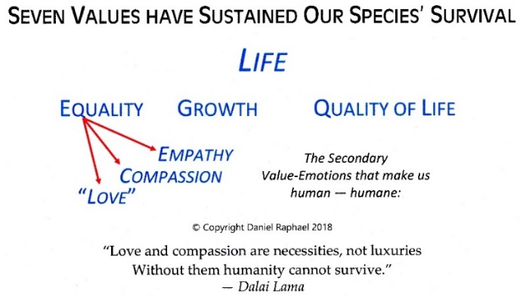
The Cultural Values of Humanity and the Social Sciences
Using cultural anthropology as an example, all social sciences will soon experience a spectrum-wide culture change due to the acceptance of the innate values of Homo sapiens as being universal and timeless to all people past, present, and future; irreducible in that there does not exist more basic and fundamental values underlying these seven values; immutable and unchanging as we observe from over 200,000 years of their influence that has sustained the survival of our species; and self-evident. These are the core values of the culture of humanity.
The culture change that will soon envelop all social sciences will occur very rapidly once social scientists come to the awareness that ALL existent social science theories are based on assumed values that have never been proven to be universal, timeless, irreducible, immutable, and certainly not self-evident.
IF cultural anthropology is to make a proactive cultural contribution to the maturation and social evolution of all societies, THEN it must do so using the core values of the culture of humanity.
Of all of the social sciences, cultural anthropology has a pivotal position among the other social sciences because its field of study focuses on the values, beliefs, attitudes, shared knowledge, and behaviors that always lie at the core of every culture.
The responsibilities of cultural anthropology are two-fold:
● to its own integrity as an effective and useful social science; and
● to fulfill its moral obligation to assist the dominant culture vis a vis the organizations of society to mature and evolve, thus enabling those cultures to survive, evolve, and become socially self-sustaining.
While it is a primary interest of each social science to study societies from the perspective of their own genre of study, in a maturing society it is also necessary for each social science to mature and evolve in its own right in order to make moral and ethical recommendations for organizations within the genre of the primary social institutions to mature and evolve. The intention is to motivate the continuing maturity and evolution of the societies it studies. It can do both by the inclusion of the innate seven human values, ethic, and morality into its professional culture and into the organizations of that social science.

Bibliography
The following manuscripts are relevant to this paper and developed by the author.
The Design Team Process
Understanding Social Sustainability
Making Sense of Ethics — A Universally Applicable Theory of Proactive Ethics,
Morality and Values
Reinvention of the Social Sciences
Organic Philosophy
Societal Morality
Stage 3 Democracies
Sustainable Civilizations, A General Critical Theory Based on the Innate Values
Of Homo Sapiens
References by other authors:
Samenow, Stanton E. (1994, 2004, 2014) Inside the Criminal Mind
B\ D\ W\ Y\ Books

Wright, Kurt 1998 Breaking the Rules – Removing the Obstacles to Effortless High

Performance CPM Publishing, Boise, ID ISBN: 0-9614383-3-9
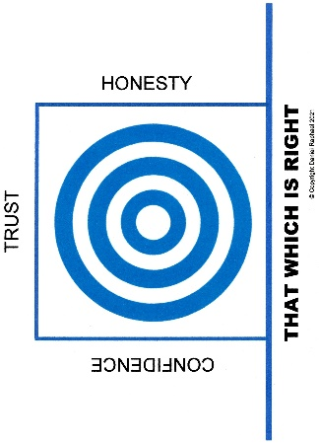
Maslow, Abraham H. A Theory of Human Motivation Open source.

“self” as a single word is identified in this paper as our self-identity. It is distinguished from “myself,” “ourselves,” and similar usages to indicate the inner personality identity.
Raphael, Daniel (2014-2018) Understanding Social Sustainability.
Maslow, Abraham 1943 A Theory of Human Motivation (Open source.)
Raphael, Daniel 2022 Stage 3 Democracies
Raphael, Daniel 2018-2022 Making Sense of Ethics — A Universally Applicable Theory Of Proactive Ethics, Morality, and Values
Ibid. Making Sense of Ethics ….
Raphael, Daniel 2022 Organic Philosophy
Raphael, Daniel 2022 Consciousness of the New Era
Wright, Kurt 1998 Breaking the Rules – Removing the Obstacles to Effortless High Performance CPM Publishing, Boise, ID ISBN: 0-9614383-3-9 Also, see the illustration on page 40.
Raphael, Daniel 2014-2022 Family Learning Centers for Sustainable Families
Raphael, Daniel (2018-2012) Making Sense of Ethics, A Universally Applicable Theory of Ethics, Morality, and Values
Raphael, Daniel (2020) Seven Innate Human Values [Available as a downloadable PDF at https://sites.google.com/view/danielraphael/free-downloads ]
Samenow, Stanton E. (1994, 2004, 2014) Inside the Criminal Mind B\ D\ W\ Y\ Books

